**PROJECT REPORT**

**Project Title:**

Competitive Analysis of Leading Travel Aggregators.

**Team ID**: LTVIP2023TMID00428

**Team Size**: 5

**Team Leader:**TUMMAGANTI VANI

**Team Member:** PANINGIPALLI SAISRINIJA

**Team Member:** SHAIK SHAKEERA

**Team Member:** SUNKARI BHAVANA

**Team Member:** POTNURU SWATHI

**Faculty Mentor:** P.S.KURAN KUMAR

**1.INTRODUCTION**

**1.1 OVERVIEW**

Competitive analysis of leading travel aggregators is a data analytics project focused on analyzing and forecasting the expenses associated with travel aggregator and booking rate in india. The primary goal is to develop models that can accurately estimate the costs incurred by travellers and airport providers for various travelling procedures and airport stays. ¬ Data Collection and Preprocessing:

A travel aggregator is a website or platform that allows users to search and compare prices for travel-related products and services, such as flights, hotels, vacation rentals, and car rentals, from multiple providers. Travel aggregators typically provide a simple and convenient way for users to find and book travel products and services, and often offer additional features such as reviews, ratings, and photos to help users make informed decisions. Some popular examples of travel aggregator websites include Expedia, Booking.com, Kayak, and Trivago.

Online travel agencies (OTAs) are struggling to remain financially sustainable due to intense competition. To overcome this challenge, OTAs need to better engage their customers by offering them superior value propositions.

* **Data Collection and Preprocessing:**

A comprehensive dataset was collected from kaggle Which includes age,sex,region,charges,smoker,BMI. The collected data underwent thorough preprocessing to handle missing values, remove inconsistencies, and ensure data quality.

* **Exploratory Data Analysis (EDA):**

EDA was conducted to gain a deep understanding of the dataset. Visualizations and summary statistics helped in understanding the characteristics of the data and guided further analysis.

* **Creating a Flask web application:**

For Estimation and Prediction of Hospitalization and Medical Care Costs data involves building an interface where We can input relevant information, and the application will use the predictive model to estimate the medical care costs.

**1.2PURPOSE:**

Travel aggregators provide users with a consolidated view of various travel options, allowing them to compare prices, routes, and schedules from multiple providers simultaneously. Aggregators offer convenient tools like filters and sorting options, enabling users to narrow down their search based on preferences such as price, duration, departure times, and more. Travel aggregators often negotiate special deals and [discounted rates](https://www.roomex.com/blog/hotel-business-rate) with travel providers, allowing users to access exclusive offers that may not be available elsewhere. Aggregators enable travelers to compare prices across different providers, ensuring they get the best possible value for their money. Travel aggregators compile information from numerous travel providers, offering a vast selection of flights, accommodations, and Aggregators cover a wide range of destinations and offer diverse travel packages, catering to different preferences and budgets.

While travel aggregators offer a wide range of choices, they may not provide the same level of customization as booking directly with a travel provider. Special requests or specific preferences may be challenging to accommodate. Aggregators may not be able to fully cater to individual needs or preferences, as their focus is on consolidating information rather than offering personalized experience.

**KEY OUTCOMES:**

* Money Savings.
* Time Savings.
* 24*7 Services.
* Expert guidance.
* Visa& Travel Formalitie.

**2.LITERATURE SURVEY:**

Tourism has been a major social phenomenon in societies all over the world. It is driven by the human desire for new experiences, and the desire to be educated and entertained. The spread of education and the technological improvements in communication have strengthened the basic human thirst for new knowledge and experience and have fostered a desire to know more about different parts of the world.Tourism has been revolutionised with the emergence of tourism aggregators, i.e. web-based portals that provide travellers with services such as travel, accommodation, and tour planning and booking. The tourism aggregators have reduced information search costs, and have increased the awareness of tourists of potential destinations. This has enabled some innovative trends in tourism, including eco-tourism, adventure tourism, heritage tourism, medical tourism, pilgrimage tourism, and so on.

 The objective of the study is to compare the competitiveness of Indian tourism aggregators using the Analytic Hierarchy Process (AHP). AHP is a technique that is used to structure multi-criteria decisions, allowing both quantitative and qualitative comparisons between alternatives (Saaty and Forman, 1992; Saaty, 2008). The criteria used for the study include price, process, ease of access, and customer service. The tourism aggregators selected for the study include Yatra, Makemytrip, Goibibo, Cleartrip, Expedia, and Kuoni-SOTC. Keywords: Tourism Aggregators, Travel Accommodation, Tour Planning, Analytic Hierarchy Process International Journal of Marketing and Business Communication.

Online travel agencies (OTAs) are struggling to remain financially sustainable due to intense competition. To overcome this challenge, OTAs need to better engage their customers by offering them superior value propositions. This calls for an in-depth understanding of the consumption values pertinent to the OTA context.

To address this gap, the current study puts forward a framework for predicting purchase intention by adapting the theory of consumption values to the OTA context. The proposed model is tested with data collected from 809 OTA users. The results imply that quality-of-benefits, monetary, social status, preference, and information values predict purchase intention toward OTAs, with the chief driver being the quality-of-benefits value, followed by the preference value. Moderation analysis further reveals that the strength of the relationship between these values and purchase intention differs between users in different age groups and between users with different levels of privacy and security concerns, hygiene consciousness, and visibility perceptions.

The results suggest that all of the proposed values have a positive association with purchase intention, but the main driver of intentions is quality-of-benefits value, followed by preference value. Moderation analysis reveals that the strength of the relationship between values and purchase intention is different for users of different age groups who have different levels of privacy and security concerns, hygiene consciousness, and visibility perceptions.

**2.1 Existing problem:**

Industry participants also leverage OTAs to reduce their cost of customer acquisition. Additionally, they are also one of the largest contributors to online marketing spends. Considering the influence that OTAs have on travel marketplaces, it is not surprising to see this segment of the industry witnessing a high degree of competitive intensity which in turn brings pressure on profitability. This is especially true in hypercompetitive marketplaces in India and the Middle East.

**2.2 proposed Solution:**

IBEs and custom extranet [software to travel agencies in India](http://www.travelomatix.com/), USA, Middle East and other key locations. The business vertical of travel and hospitality, has seen a tectonic shift in usage of technology over last ten years. Travel companies, no longer follow the traditional process for booking travel Travelomatix is a leading travel technology solutions provider, offering travel portals, deals for customers and corporates.

As the travel and tourism sector around the world continues to experience overall robust growth, private and public retailers in this sector; namely the travel agencies, are gearing themselves to handle the brimming business. There are several challenges being faced by travel agencies run by—Thomas Cook, Mystifly, SOTC, and other global leaders in the travel business.

A majority of the challenges are associated with the operations involved in the travel agency business. With the growing demand for exclusive travel opportunities, these travel agencies are being riddled with some major stumbling blocks. Here’s a look at the top five most critical operational challenges for travel agencies.

Tourism is emerging as one of the biggest human resource absorbing sectors providing millions of job opportunities, investment opportunities, and business avenues for travel agencies. Acting as an intermediary or even one-stop solution for clients, travel agencies have to cater to a large audience on a daily basis along with humongous data management.

Invoicera was made familiar to the existing conundrum of these travel agencies through one of our clients. They came with several invoicing problems along with challenges to manage their staff, vendors, and clients. Every business tries its best to capture maximum market share in order to extend the best in industry services, but such challenges often render them helpless to overpowering issues.

**3.THEORITICAL ANALYSIS:**

**3.1 Block Diagram:**

Creating a detailed block diagram for Competitive Analysis of Leading Travel Aggregators involves breaking down the process into key steps and components. Below is a high-level block diagram outlining the main stages and elements involved in competitive analysis of leading travel aggregators.

The block diagram illustrates the end-to-end process of competitive analysis of leading travel aggregators, starting from data collection and preprocessing to deploying the final models for competititve analysis of leading travel aggregators.

The block diagram illustrates the end-to-end process of estimating and predicting hospitalization and medical care costs, starting from data collection and preprocessing to deploying the final models for cost estimation and future cost prediction.

**COMPETITIVE ANALYSIS OF LEADING**

**TRAVEL AGGREGATORS**

* Specify The Business Problem
* Business Requirements
* Literature Survey
* Social Or Business Impact

**Define problem / Problem Understanding**

**Data Collection & Extraction From Database**

* Collect The Dataset
* Connect IBM DB2 With IBM Cognos

**Data Preparation**

Preparing The Data For Visualization

**Data Visualization**

The No Of Unique Visualization

**Dash board**

Responsiveness And Design O f A Dashboard

**Story**

The Number Of Scenes In A Storyboard

Creating A Report

**Report**

* Amount Of Data Rendered To DB2
* Utilization Of Data Filters
* No Of Calculation Fields
* No Of Visualizations / Graphs

**Performance Testing**

**Web Intergration**

Dashboard, Report And Story Embed With UI With Flask

**3.2 SOFTWARE OR HARDWARE DESIGNING**

**Software Requirements:**

* IBM cognos analytics Tool
* Flask
* Integrated Development Environment (IDE)-Spyder

**Hardware Requirements:**

* Minimum System Requirements(RAM-4GB,Quad core Processor Or above).

**4.RESULT**

**DATA VISUALIZATIONS:**

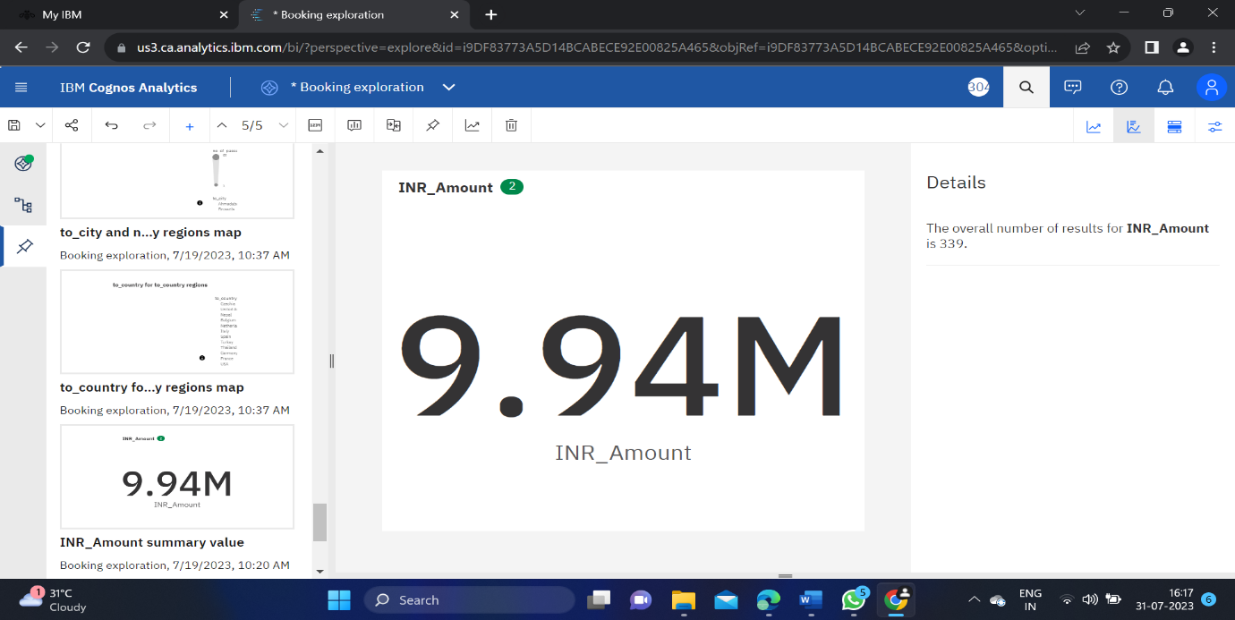

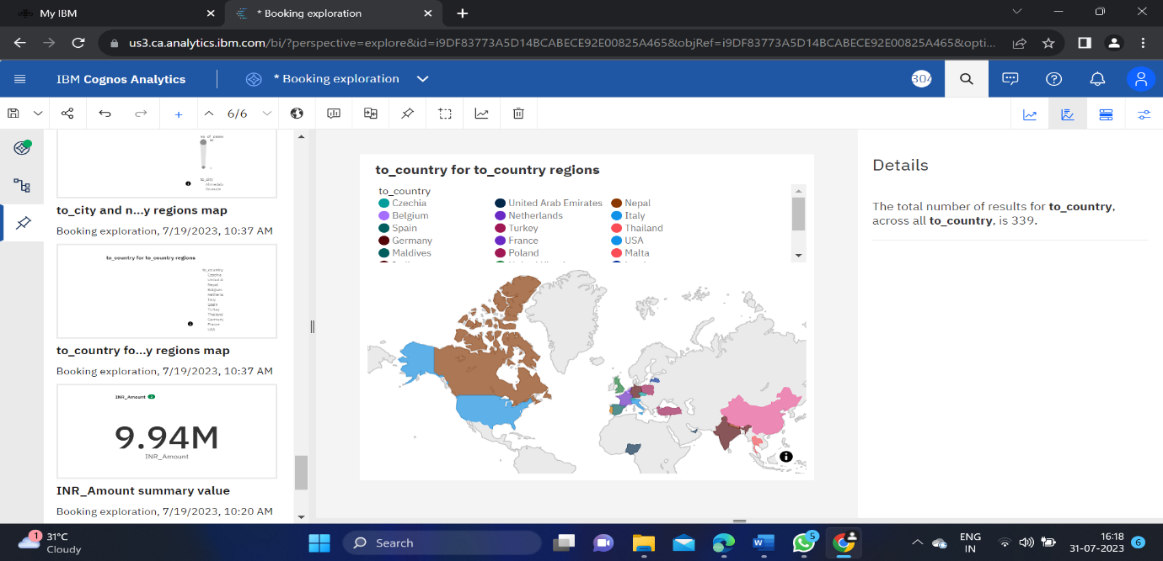

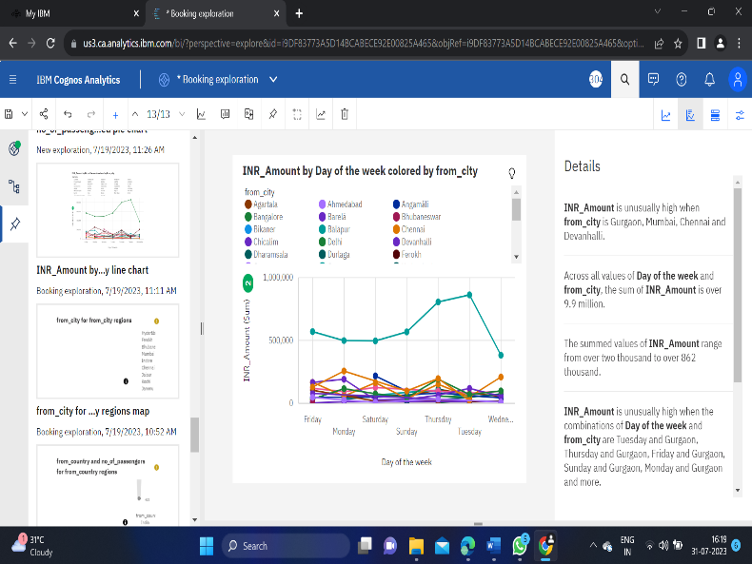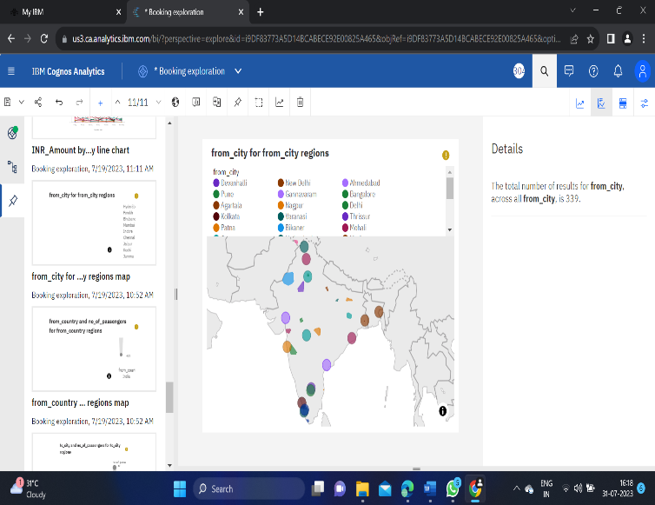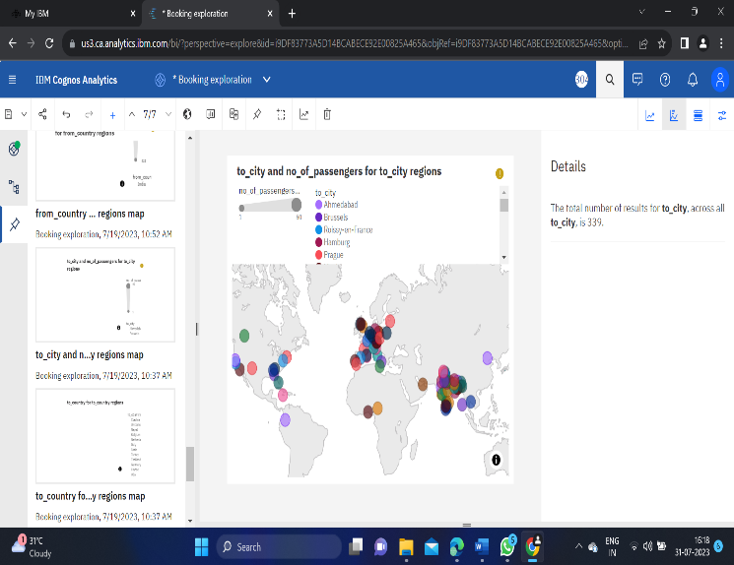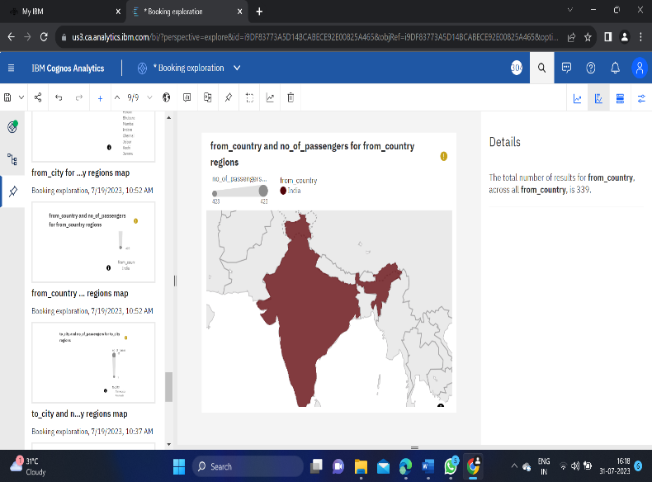

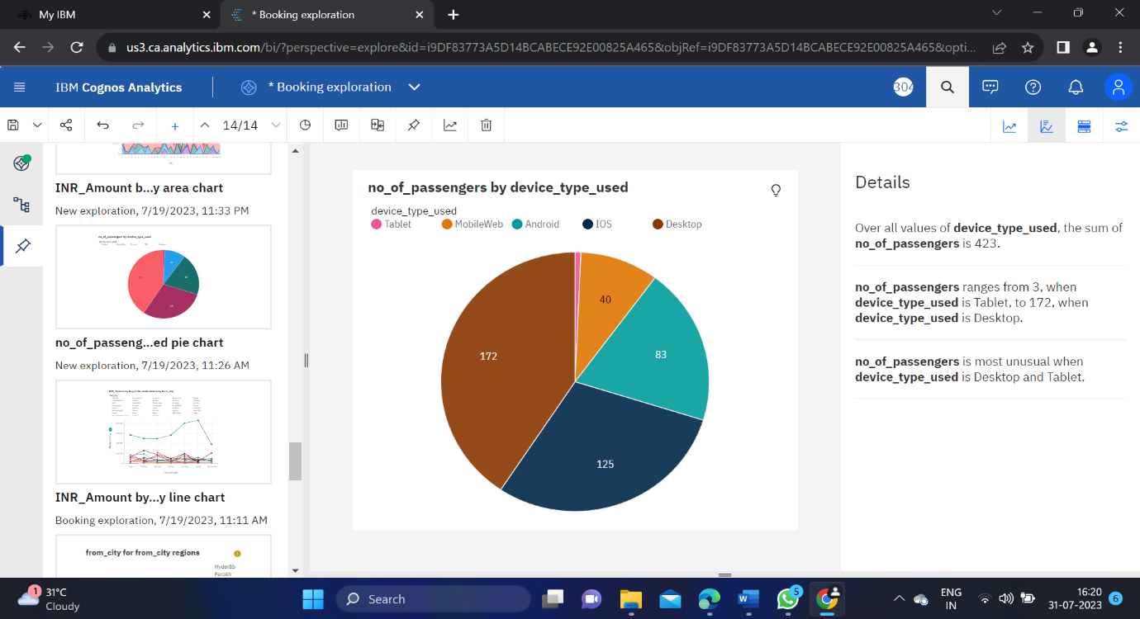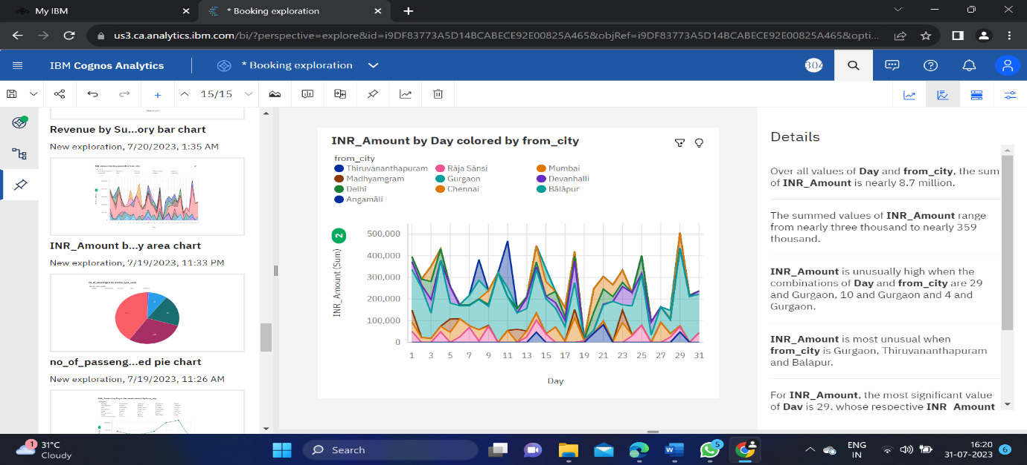

**Booking Dashboard**

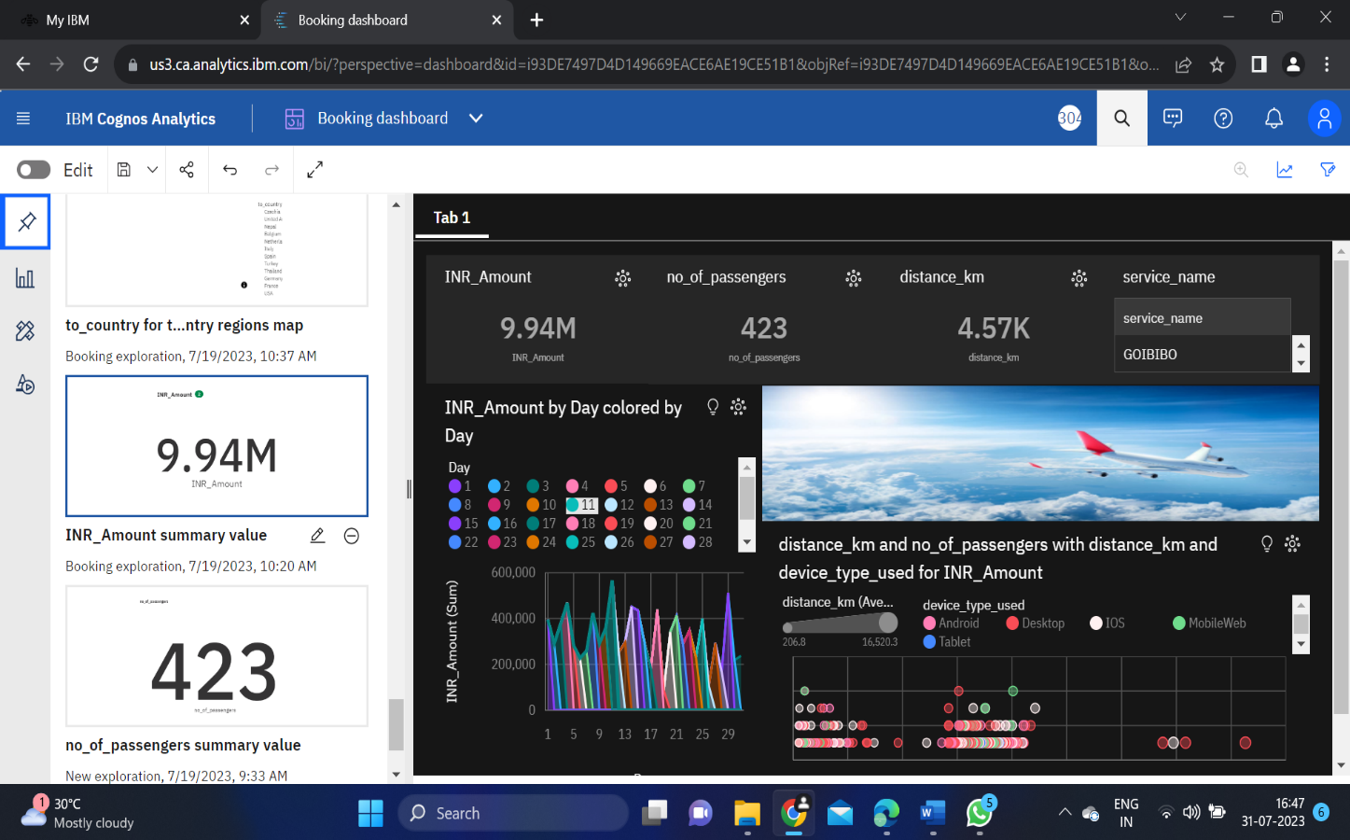

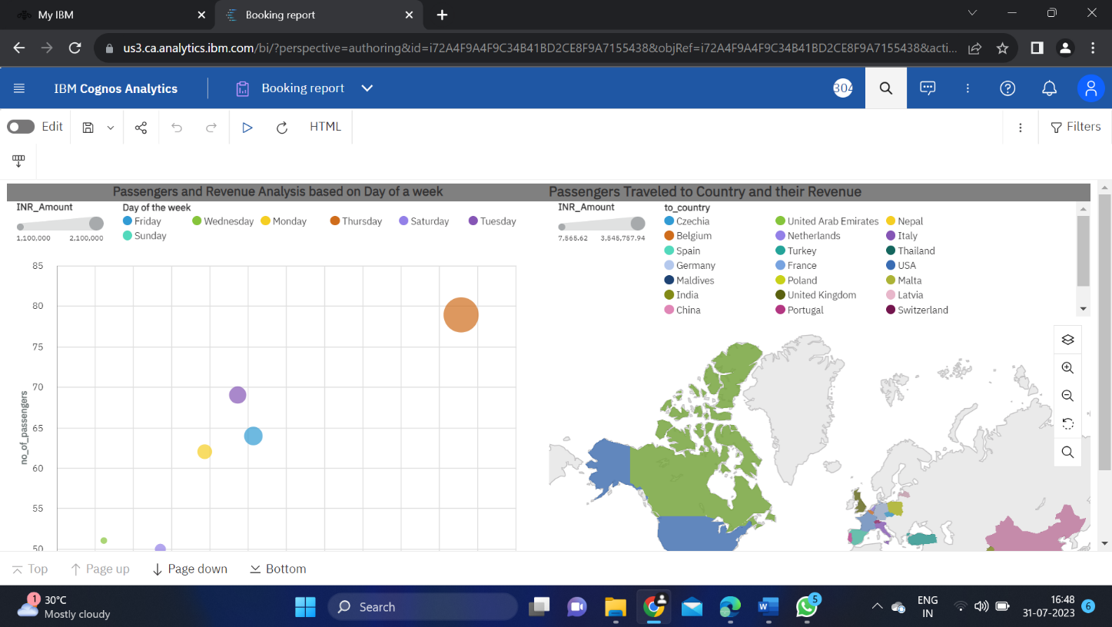 **Booking Report**

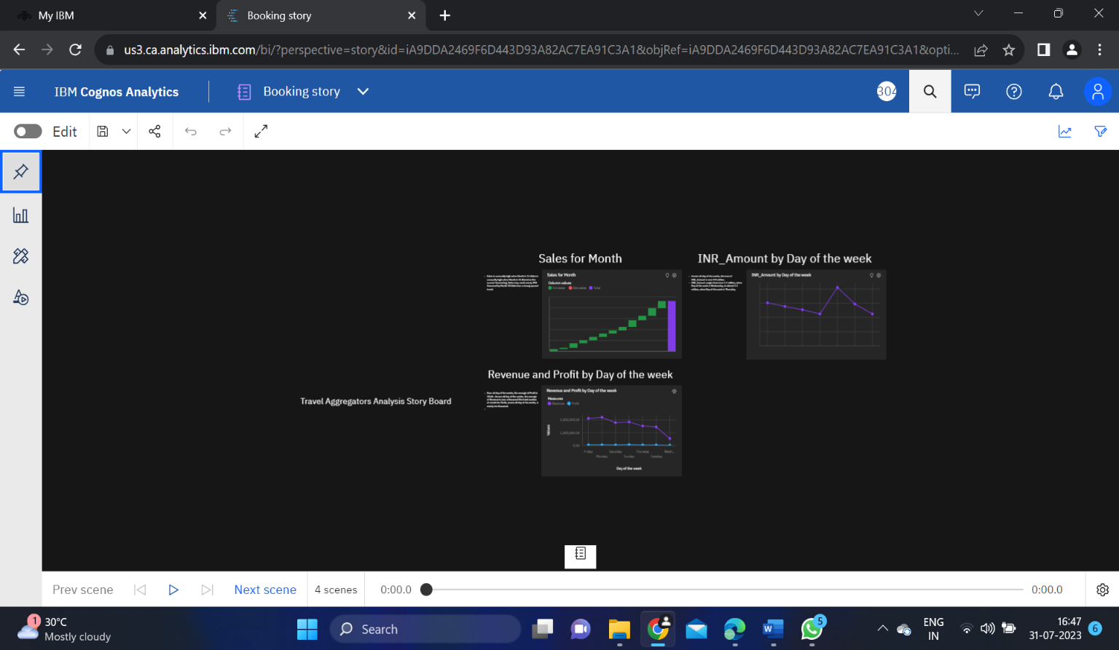 **Booking Story**

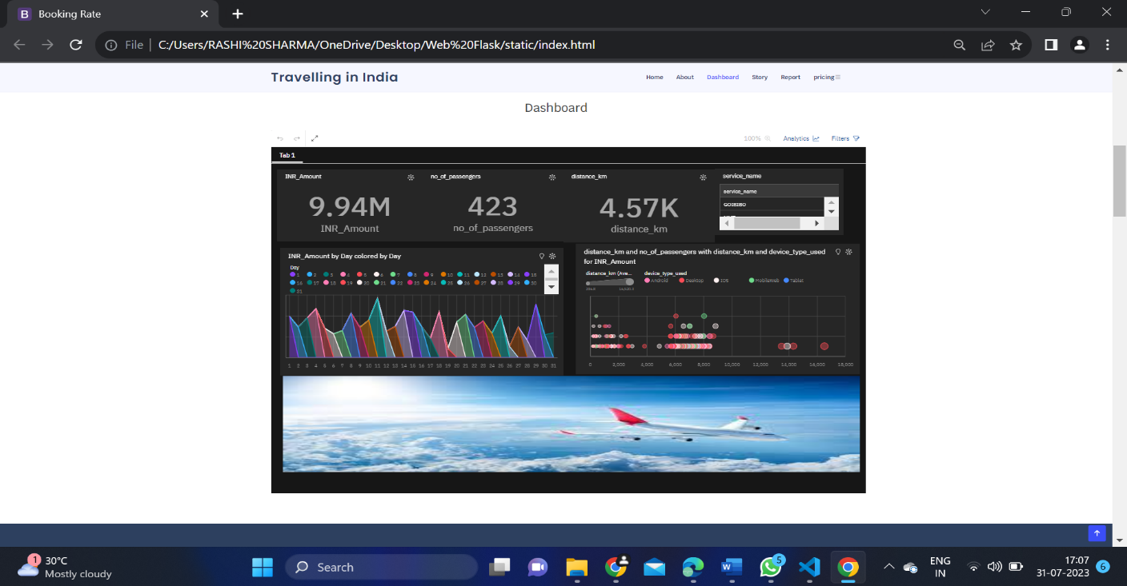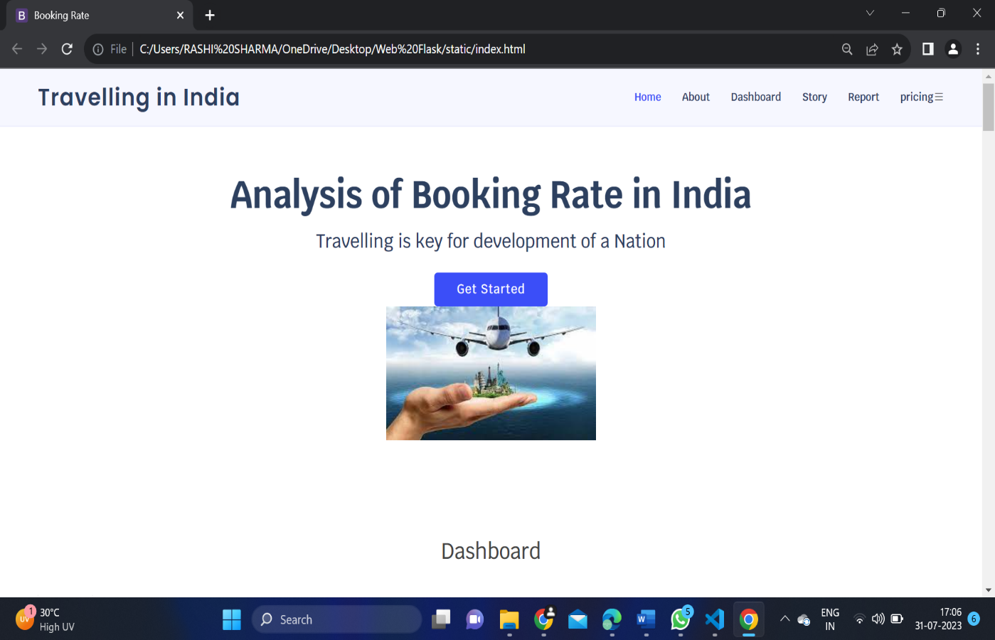 **WEB INTEGRATION**

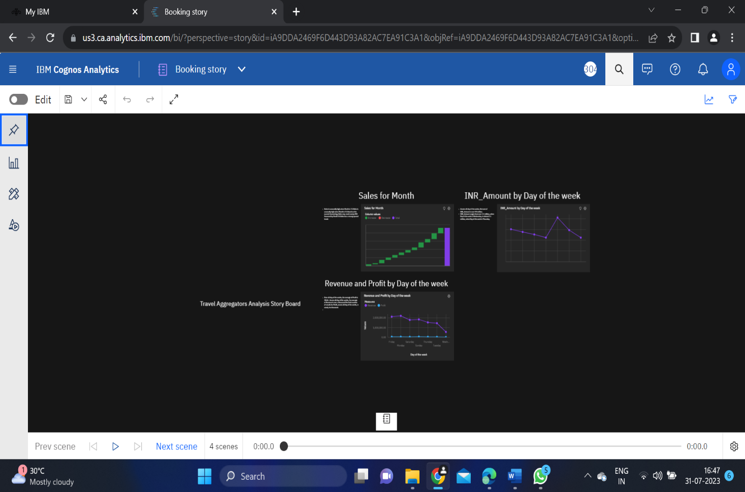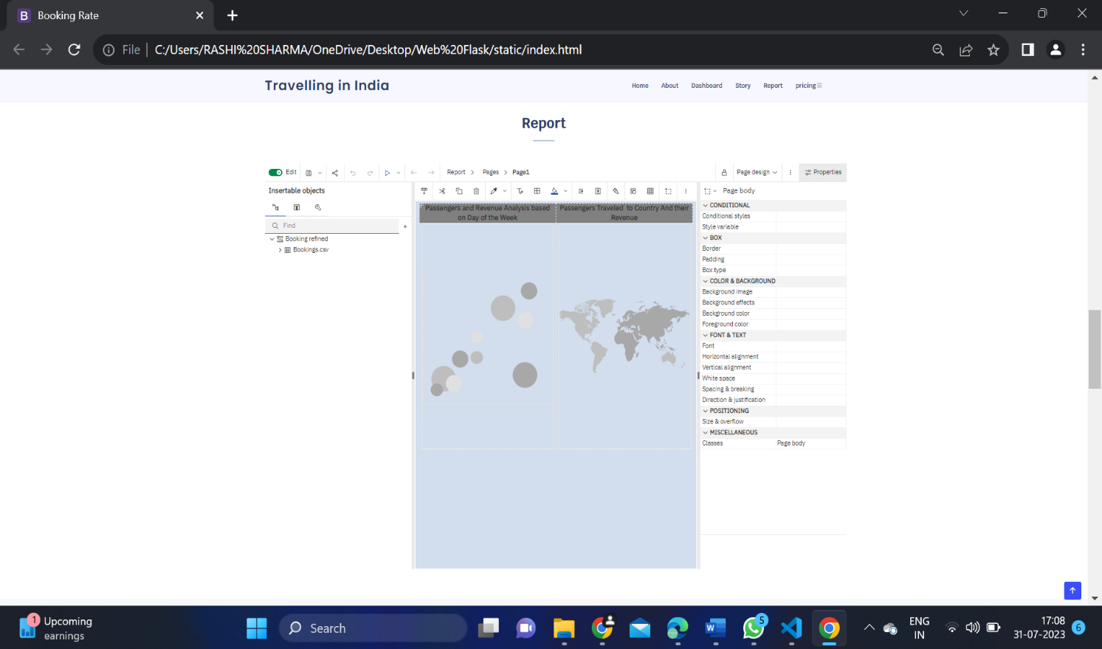

**5.ADVANTAGES:**

* Expand your reach.
* Create marketing efficiencies.
* Generate more low season bookings.
* Gain invaluable insights.
* Having to pay a commission.
* Customer service issues and cancellation rules.
* Risk of overbooking.
* Potential loss of business.

**6.DISADVANTAGES:**

### **Customer service issues and cancellation rules.**

### **Risk of overbooking.**

### **Potential loss of business.**

### **Loss of complete control.**

**6.APPLICATIONS:**

The Compititive Analysis of Leading Travel Aggregators project has several valuable applications in the travelling industry and beyond.

* Free signup.
* Smart dashboard.
* New sales channels (Trip Advisor, Citibank, HDFC bank, and Kotak Customers).
* Support of hotel chain management.
* Competition monitorin.
* Availability tracker.
* Comprehensive dashboard.
* Easy way to list your accommodations.
* Support for listing transportation.
* Use Booking.com with Ixigo to streamline collaboration.

**7.CONCLUSION:**

The Tourism industry is the largest service industry in India and has the potential to stimulate the economic growth of the country. It becomes important for all citizens to develop the Tourism infrastructure and maintain tourist destinations, railway stations, airports, rest houses, and hotels.

**8.FUTURE SCOPE:**

Innovation and technology in travel agency business – In the new normal, people are looking for personalized service along with convenience of technology. There is a large opportunity to empower agents and small travel firms with best priced inventory, websites, digital payments and other tools.

The travel intermediaries business market is anticipated to flourish at a steady CAGR of 6.0% between 2023 and 2033. The market is expected to hold a market share of US$ 899.7 million by 2033, while the market is likely to reach a value of US$ 502 million in 2023.

Tourism industry contributes to 9% of the global GDP and offers one from every 11 jobs. In addition, the number of tourists have doubled over the past 20 years and a propelling growth is expected in coming few years among all market segments. Tourism industry has an intense potential to grow and generate revenues.